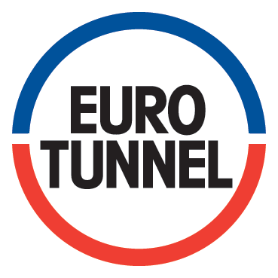 | DEP
 | DEP

ENGLISH TITLE
Analysis of the risks associated with the use of a water mist inside a PAX Shuttle

AREA OF APPLICATION | SCOPE OF APPLICATION
[Function/Department applying the document / Fonction appliquant le document].
Applicable with effect from / date d'application:

Original language / Langue d'origine: | EN ☐ | FR ☒ | Other / Autre

ADDITIONAL INFORMATION |  |  | ADDITIONAL INFORMATION
Modification: | Complete Review / Revue complète | ☐ | Major | ☐ | Minor / Mineure | ☐

Rev. | Author / Auteur | Checker / Vérificateur | Safety Directorate Check  Safety Department Audit | Approver / Approbateur
 | Name/Nom - Sig./Visa - Date | Name/Nom - Sig./Visa - Date | Name/Nom - Sig./Visa - Date | Name/Nom - Sig./Visa - Date
 | XXXXX (Div/Dept) | XXXXX (Div/Dept) |  | XXXXX (Div/Dept)
 |  | XXXXX (Div/Dept)
 | DD/MM/YYYYY | DD/MM/YYYYY | DD/MM/YYYYY | DD/MM/YYYYY

REFERENCE DOCUMENT |  |  |  |  | DOCUMENT IDENTIFICATION |  |  |  |  | IMPR/2757/4 - 04/2023
WBS | LOC | DIS | ORIG | SERIAL |  | REV | TYPE | STATUS | LEVEL | IMPR/2757/4 - 04/2023
XXX | XXX | XXX | ORIG | SERIAL |  | REV | AAA | XXX | XX | IMPR/2757/4 - 04/2023
This document is the exclusive property of Eurotunnel (a joint venture company comprising France Manche SA and Channel Tunnel Group Ltd.). Any use thereof must be subject to the prior and express authorisation of Eurotunnel.  This document is the exclusive property of Eurotunnel (a joint venture between France Manche SA and Channel Tunnel Group Ltd). Any use or exploitation must have the express prior authorisation of Eurotunnel. |  |  |  |  |  |  |  |  |  | IMPR/2757/4 - 04/2023

LIST OF REVISIONS / LISTE DES REVISIONS
Rev. | Date | Changes | Author / Auteur  Signature | Checker / Vérificateur  Signature | Approver / Approbation

EXTERNAL CHECKS / VERIFICATIONS EXTERNES
Rev. | Date | Body / Responsible Group | Name / Nom

LIST OF EFFECTIVE PAGES / LISTE DES PAGES EFFECTIVES
Page | Revision

TABLE OF CONTENTS
Page
Front page1
List of Revisions2
List of Effective Pages2
Table of contents3

1. Background 4
2. System definition 4
3. Conditions of use of the Shuttle before connection of the dry standpipe to the hydrants 6
4. Identification of risks associated with the use of water mist 6
5. electrical risk assessment 7
1.1 description of PAX electrical distribution 7
1.2 Electrical risk assessment 9
6. assessment of the risk of liquid effluents 11
7. conclusion 11
8. 12
9. 12
10. 12
11. 12
12. Appendix 1 12

Context

During the preliminary risk analysis (Ref.: OPMV-0802), safety requirement "FDE-20" highlighted the need to study the options for controlling an electric vehicle (EV) fire:
FDE-20: The performance of the on-board extinguishing systems must be such as to bring an electric vehicle fire under control.

The idea of supplementing the "Novec 1230" extinguishing system with a "dry column" follows the first "Novec 1230" test campaign carried out at the end of 2019 on the CNPP site. This involves installing a network of nozzles on board the wagons (as illustrated below) which, once connected to the external water supply, can diffuse a mist of water into the wagon in order to :

- Cooling and containing an electric vehicle battery fire.
- Cooling the atmosphere in the wagon.
- Capture and reduce smoke and decomposition products associated with fire and the use of Novec 1230.

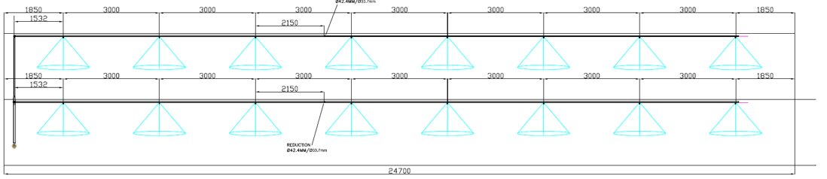
Figure 1Initial concept of a dry column

The concept of installing a network of pipes and nozzles has been validated with ALSTOM, which is responsible for physically integrating the system into the PAX shuttle.

The use of the dry stack requires a physical interface between this network of dry stack pipes and the hydrants available on the concession.

This physical interface is the subject of the study described in this document and contributes to the production and/or modification of emergency response procedures in accordance with safety requirement "DPS-1" indicated below:
DPS-1: The emergency plans and procedures to be followed by the emergency services in the event of an emergency must be updated to take account of the changes made under the PAX OPMV programme.

Reference documents

EN 50153 - Railway applications - Rolling stock - Protective measures against electrical hazards
FORT-0269 Risks associated with the electrical distribution of Rolling Stock - Trainer's Guide

System definition

The "dry column" system consists of a network of pipes connected to the hydrants available from outside the Shuttle, and distributing a mist of water through nozzles inside the PAX carriages.
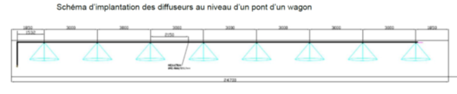
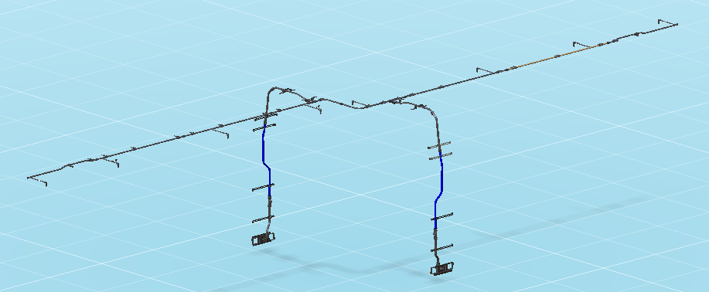
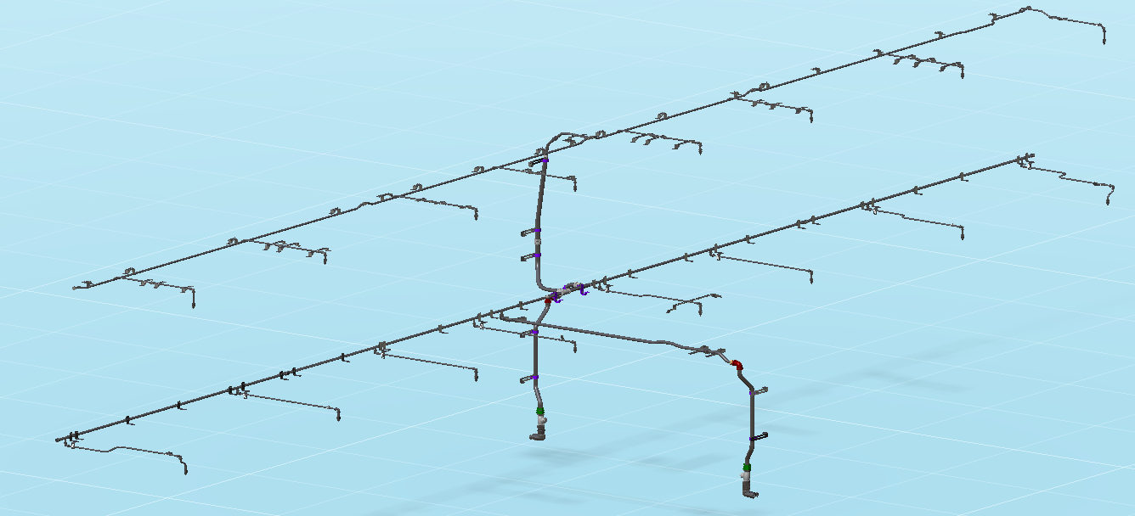

The water mist will spread out inside the vehicle in the form of cones to cool the atmosphere in the event of a fire. The water that remains liquid will run down the walls or onto the vehicles before being collected by the drainage system.

Conditions for using the Shuttle before connecting the dry standpipe to the hydrants
The condition of the PAX Shuttle must be defined before the dry column is used:
- A thermal or electric vehicle caught fire inside the Shuttle
- The Shuttle's FDE system released the extinguishing gas in the wagon concerned. In the case of a lithium-ion battery thermal runaway, the extinguishing gas cannot stop the thermal reaction.
- The atmosphere in the Wagon concerned is made up of :
  - Fumes
  - Extinguishing gas
  - Extinguishing gas decomposition product
- The Shuttle is stopped either at the Fr/UK loading bay, in the Fr/UK emergency lane or in the Tunnel.
- All passengers and crew have been evacuated
- The catenary has been cut and earthed
- The emergency services operating the connection are equipped with the SCBA/PPE necessary to protect them from the smoke/gas that may emanate from the Wagon.

Identifying the risks associated with the use of water mist
Following working groups with various stakeholders, including the UK and FR emergency services, two risks associated with the use of water mist were identified:
- The electrical risk for members of the emergency services connecting the dry standpipe from the outside and located near the Wagon during the spraying phase.
- The risk linked to liquid effluents generated by water mist that may flow outside the wagon

electrical risk assessment

description of PAX electrical distribution

The wagons making up a Navette PAX are powered at 1500V from the locomotives.
The 1500V line feeds 1500V- 400V/110V electrical converters distributed along the Shuttle.
The following diagrams give an overview of the electrical distribution inside PAX shuttles

The 110V supplies power to the batteries, which provide a permanent supply even if the train is in shut-down mode (i.e. not powered by the catenary).
If the catenary is cut and earthed, only the 110V power lines will continue to be supplied from the batteries. Remember that the batteries are designed to supply power to the Shuttle's emergency systems (emergency lighting, ventilation, etc.) for at least 90 minutes.

Electrical risk assessment

All the equipment is protected by circuit breakers. If there is a short circuit downstream of the circuit breaker, it will trip automatically.
Vehicle batteries are protected by a fuse. If there is a short circuit downstream of the battery fuse, it will automatically melt.
Details of the wagon wiring diagrams and the positioning of electrical equipment are given in Appendix 1.
In addition to the electrical protection inherent in the electrical distribution of PAX Shuttles, it is advisable to consider the case of emergency services personnel who have to connect the hose leading to the hydrants to the connection on the front of the body from the outside.
In this situation, the electrical risk could come from the electrical potential of a metal part of the wagon: body, outer box, etc.
In assessing the risk, it should be remembered that all the boxes, cabinets and other metal equipment must be connected to the vehicle earth (body) in accordance with the recommendations of standard EN 50153 - Railway applications - Rolling stock - Protective measures against hazards of electrical origin. In addition, the body is connected to the rail via earth braids, current returns and bogie wheels.
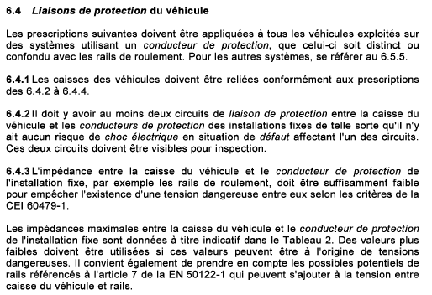
Extract from standard EN 50153

So any wire touching the vehicle body will either trip its associated circuit breaker or blow the battery fuse. In either case, the body will always be connected to the rail.
There is no danger of electrification for a member of the emergency services connecting the dry column.

assessment of the risk of liquid effluents

Description of the water mist and effluent evacuation capacities
Using the data from document OMV 4672 - Complementary fire protection process for PAX wagons - Water mist diffusion system, the following volumes of water must be taken into account for each type of vehicle and as a function of the pressure at the inlet to the dry column:
DD vehicle: between 402 and 529 l/mn
SD vehicle: between 200 and 263 l/mn

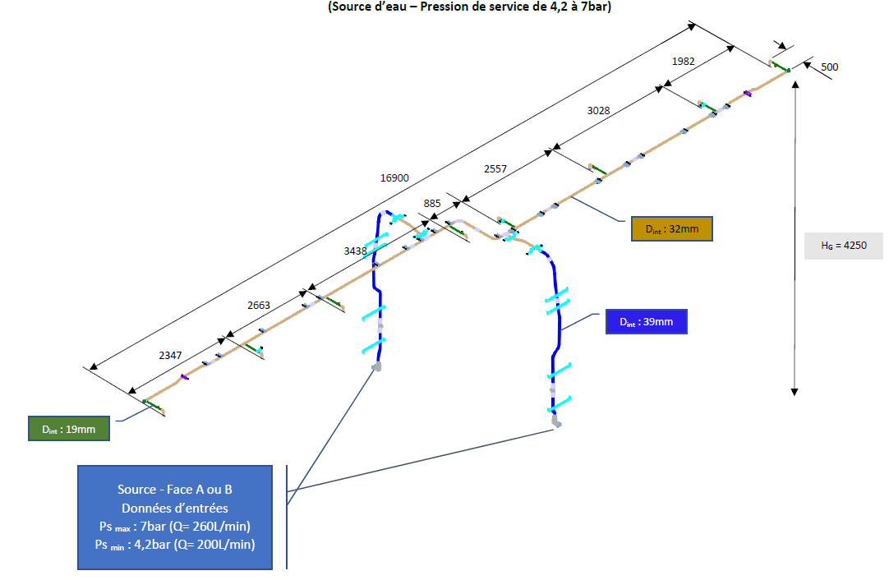
OPMV4672 extract for an SD vehicle

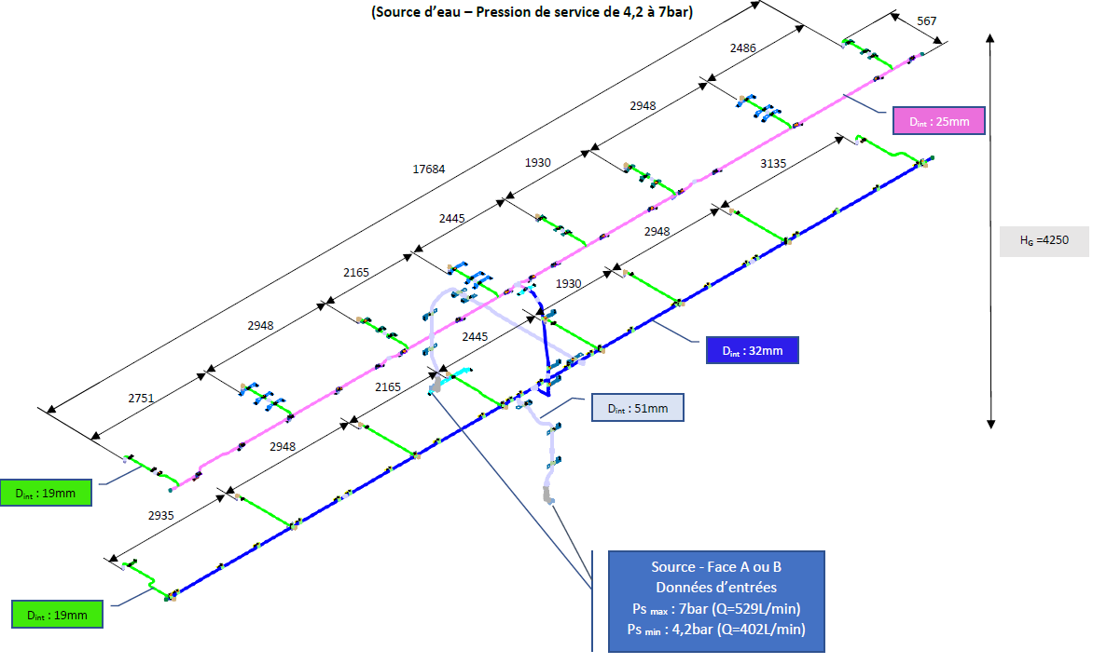
OPMV4672 extract for a DD vehicle

DD and SD vehicles are equipped with two 250l tanks for collecting effluent. These tanks are equipped with an overflow which is used when the maximum capacity is exceeded.
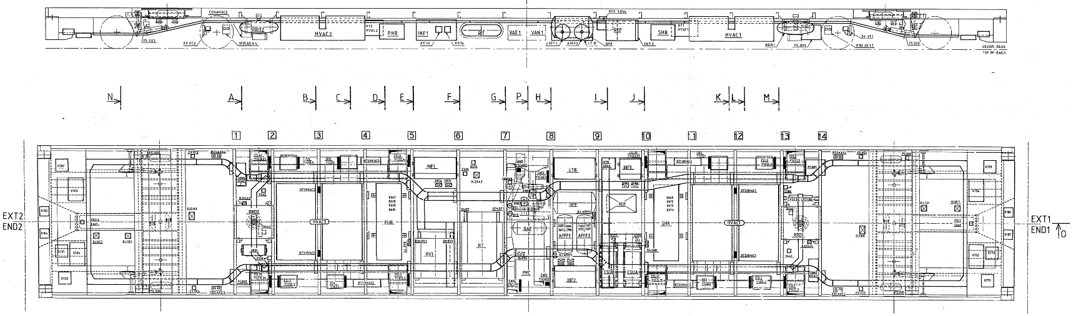
In the middle of each deck, there is a drain pan running the full length of the vehicle. This tray has a capacity of 100l (TBC).
The air-conditioning ducts under the pavement are located above the drainage tray. In the event of fire, these are sealed by watertight valves, whose closing principle guarantees watertightness even under pressure.
The blower door tests showed that the leak tightness of the wagons was 3400m3/h for the DD vehicles and XXXm3/h for the SD vehicles at 50kPa. However, it is not possible to determine the precise location of the sources of leakage, although it is likely that fire doors, cable and pipe penetrations and air-conditioning duct penetrations are major contributors.

Scenario analysis
Based on the above data, we can conclude that :
- After one minute for DD vehicles and two minutes for SD vehicles, the drainage tanks will be filled and their overflow will start discharging effluent under the chassis.
- The water will continue to rise, first in the drain pan, then covering the floor before flowing into the air-conditioning ducts.
- It is likely that other sources of leakage under the chassis will appear in the form of leaks at cable or pipe penetrations or around air-conditioning ducts.

For a DD vehicle, the length between PCFs is 24.5m, the width between kerbs is 2.088m, the step between the floor and the kerb is 38mm, giving a volume of 1.9m3 per deck. With a water volume of 250l/min/bridge, it will take approximately 8 minutes to exceed the height of the pavement and reach the level of the emergency door thresholds.

conclusion

Appendix 1
Details of wiring diagrams and location of electrical equipment by vehicle type

Batteries and fuses
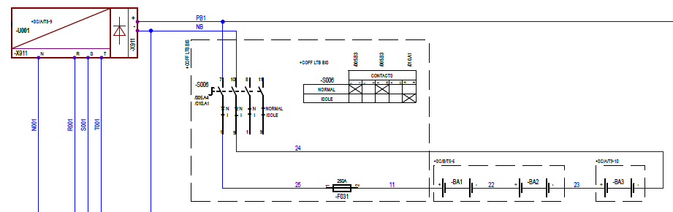
Location under chassis
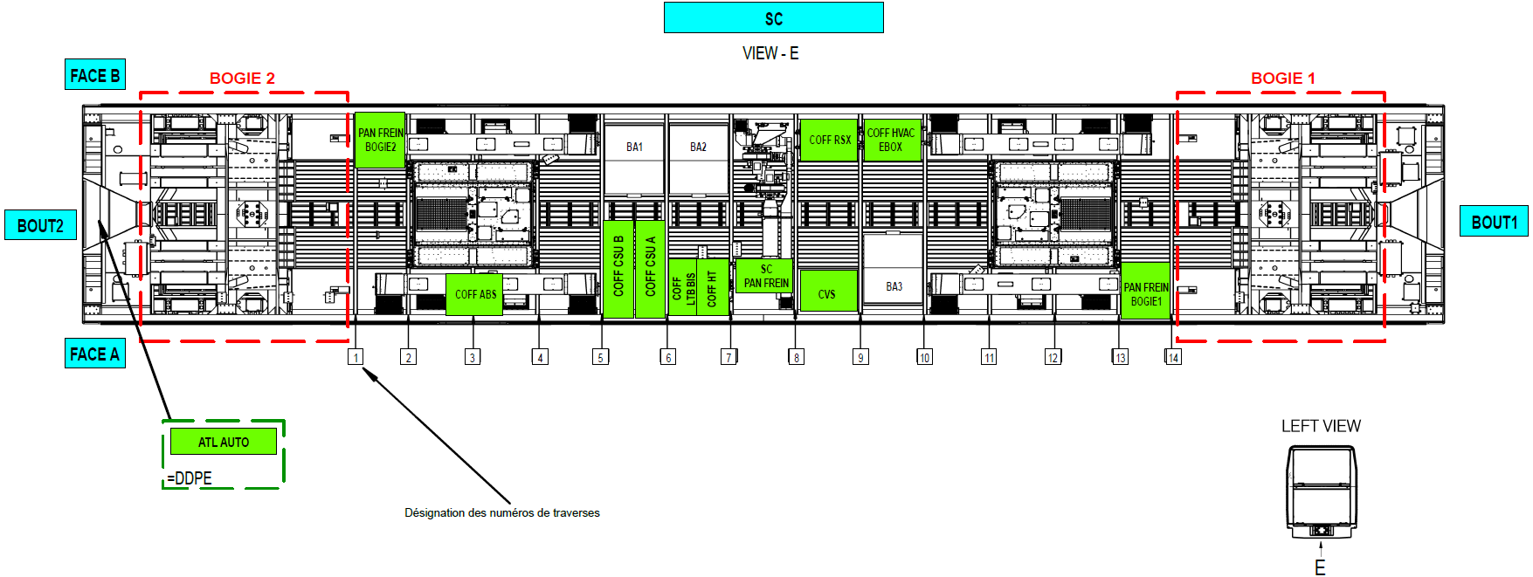
110V distribution
Permanent power supply even if the train is in shutdown. If there is an occupied position, all circuits are powered.
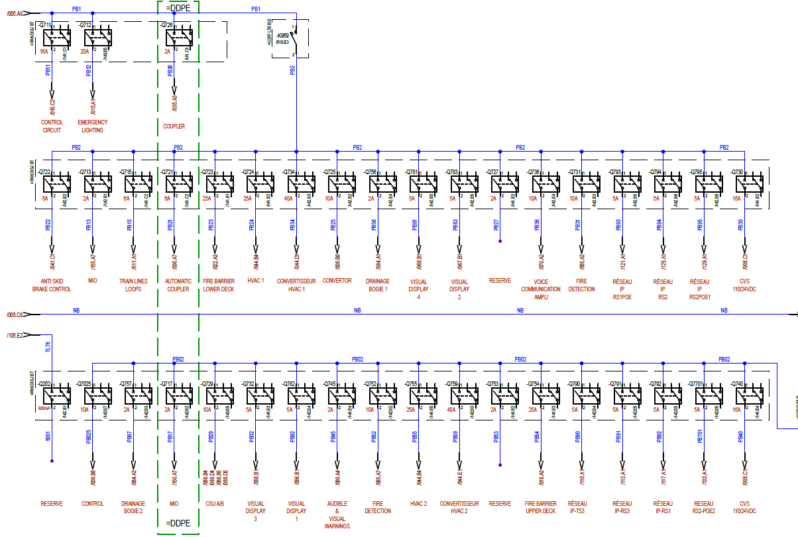
Location of LV circuit breakers
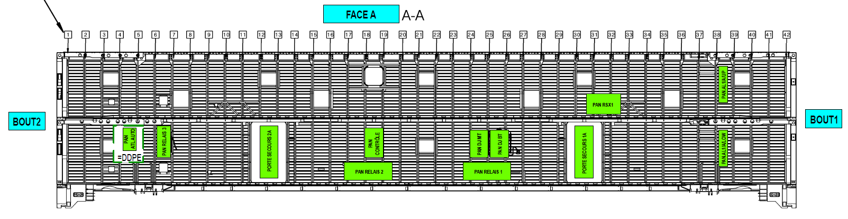

DDPC
There are no batteries
110V distribution. The permanent power supply is functionally identical to that of the DDPEAI.
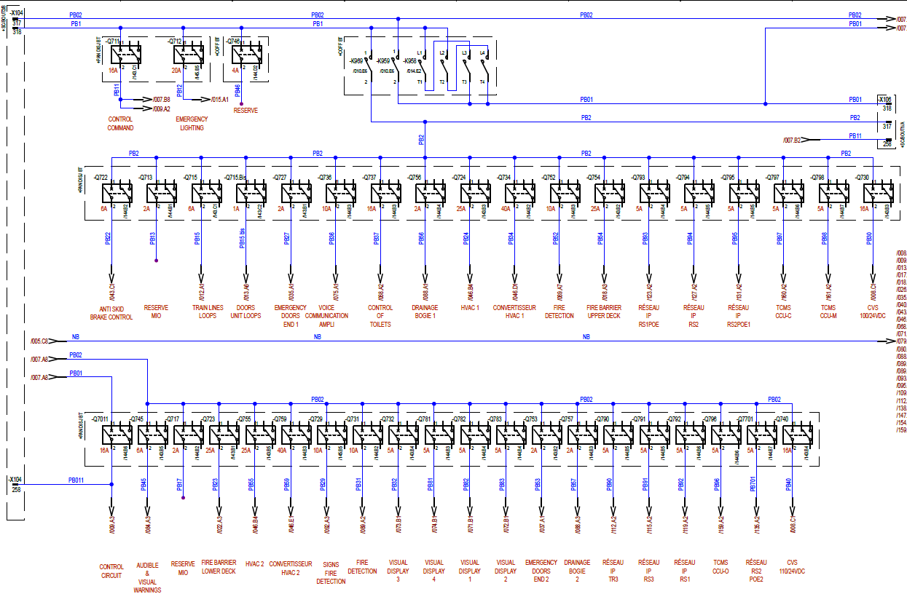
Location of LV circuit breakers
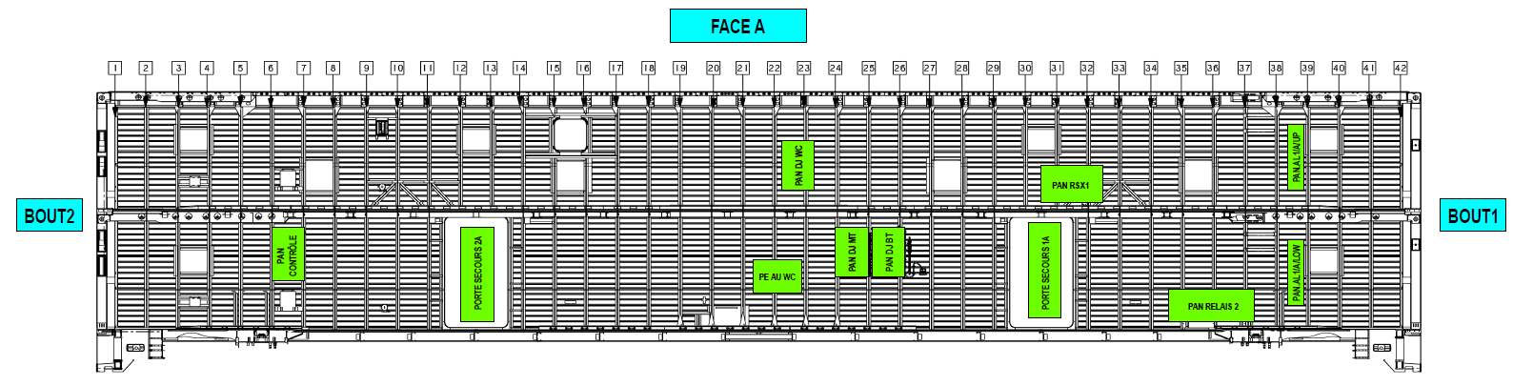

SDPEAI
Batteries and fuses
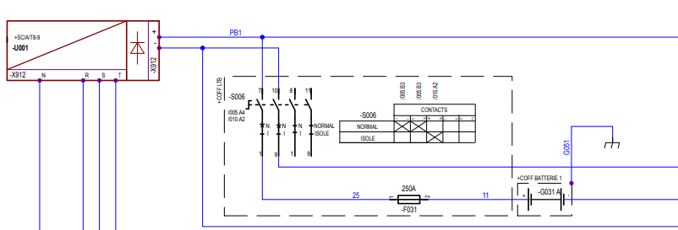
Location under chassis
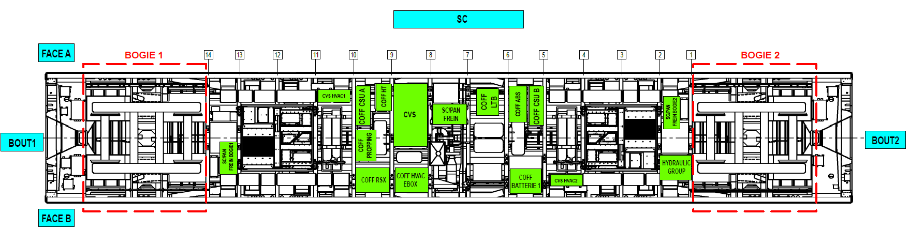

110V distribution. 110V distribution. The permanent power supply is functionally identical to that of the SDPEAI.
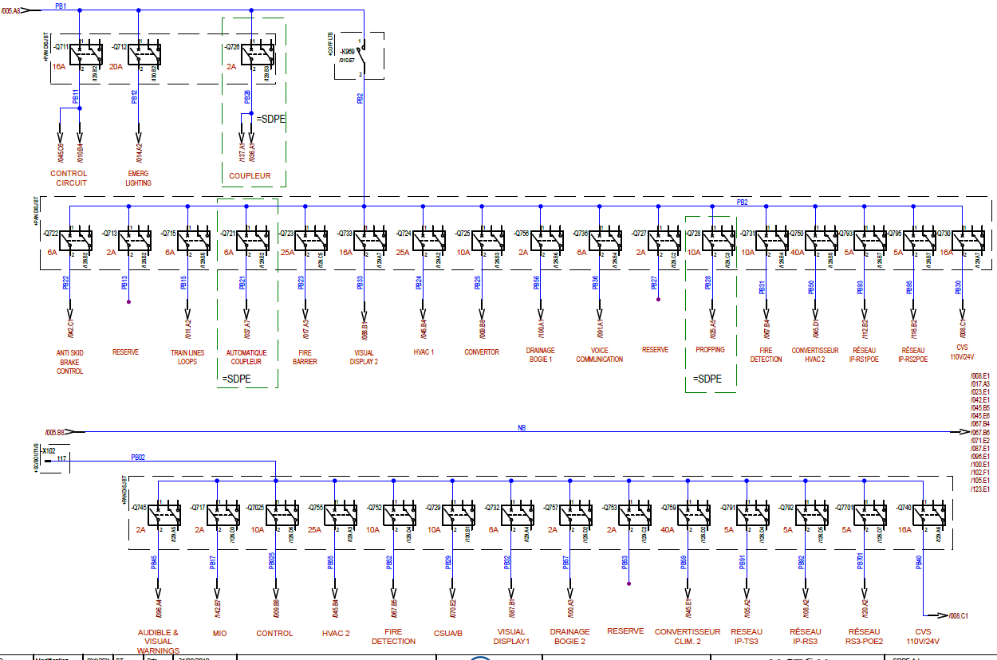
SDPC
Batteries.
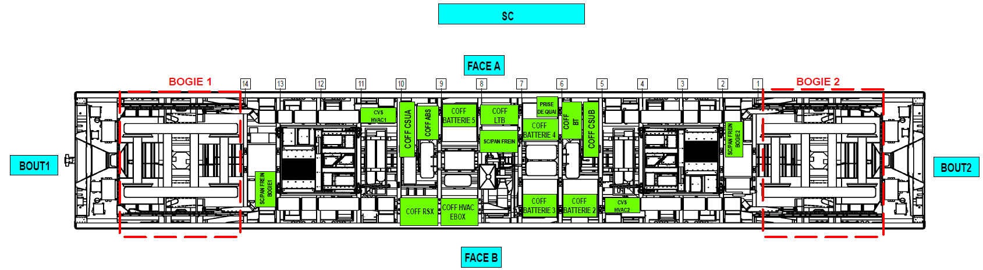

110V distribution. The permanent power supply is functionally identical to that of the SDPEAI.
